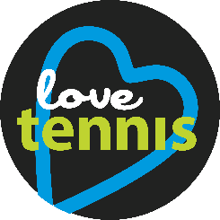 | Miscellaneous ideas for your  Love Tennis Weekend 2021

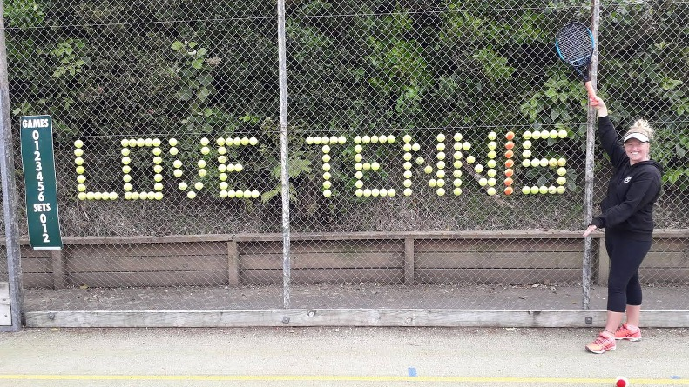
Ball display on fence
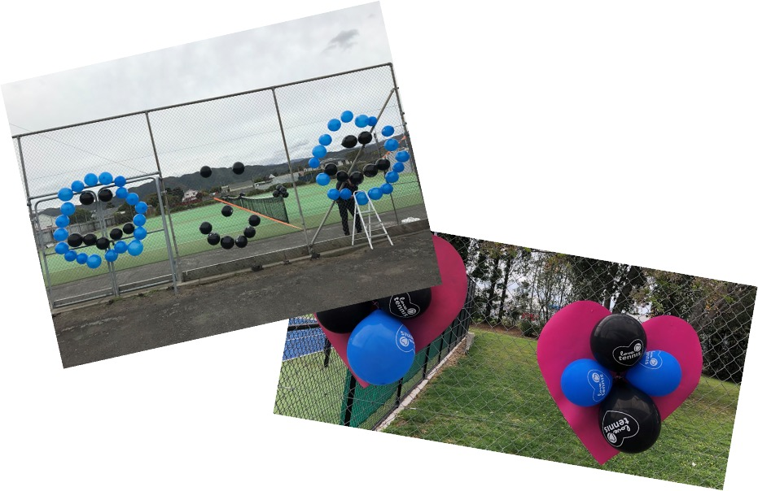
Balloon displays

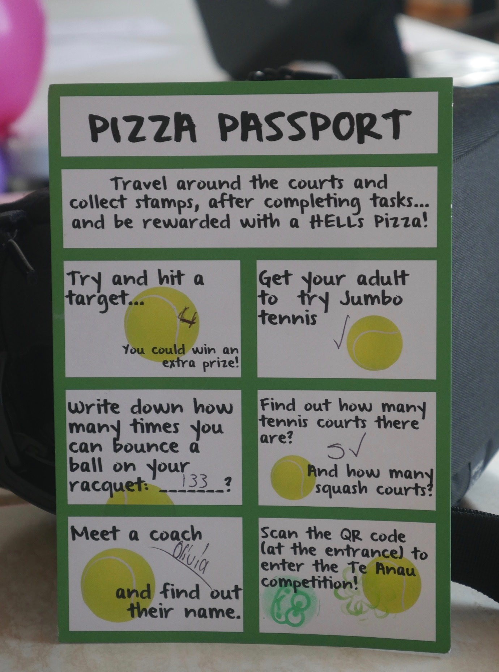
Pizza passport

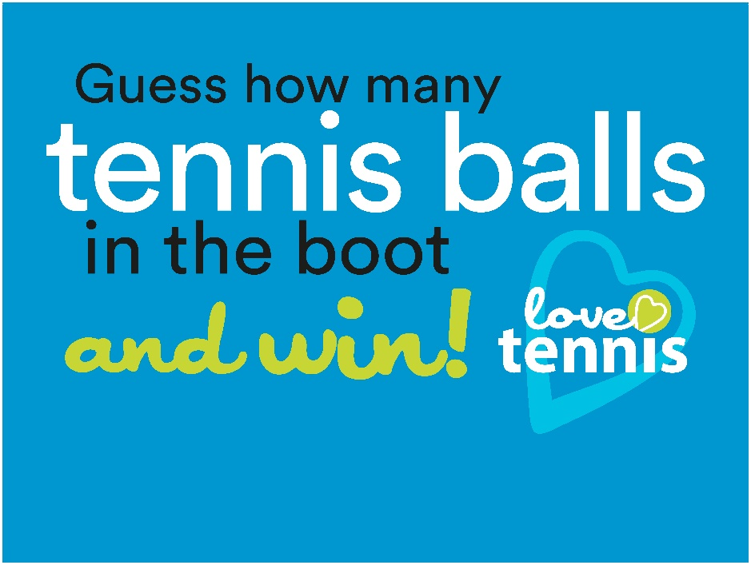
Guess and Win!
Printable “Guess and Win” sign >>


Printable Love Tennis brainstorm slides >>

