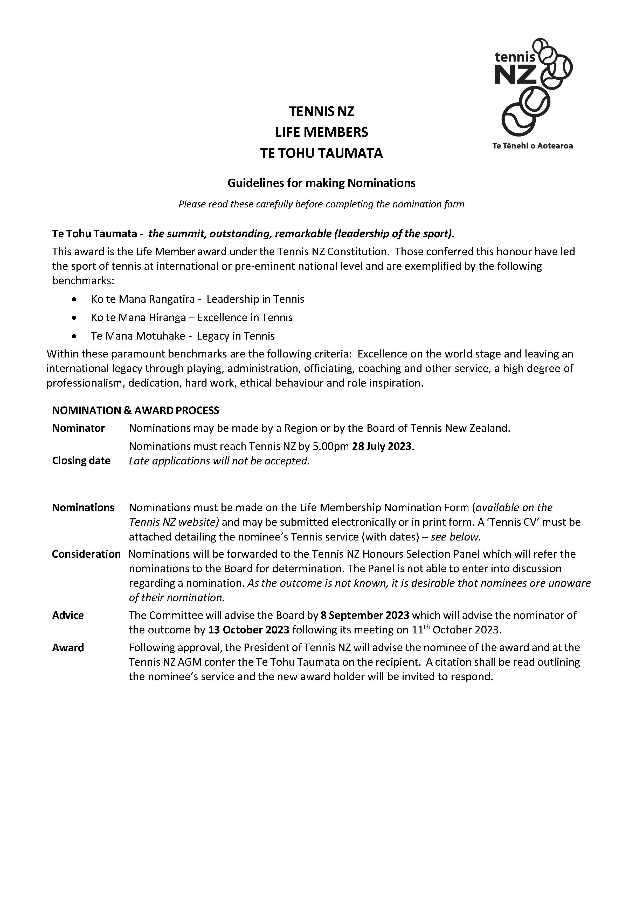

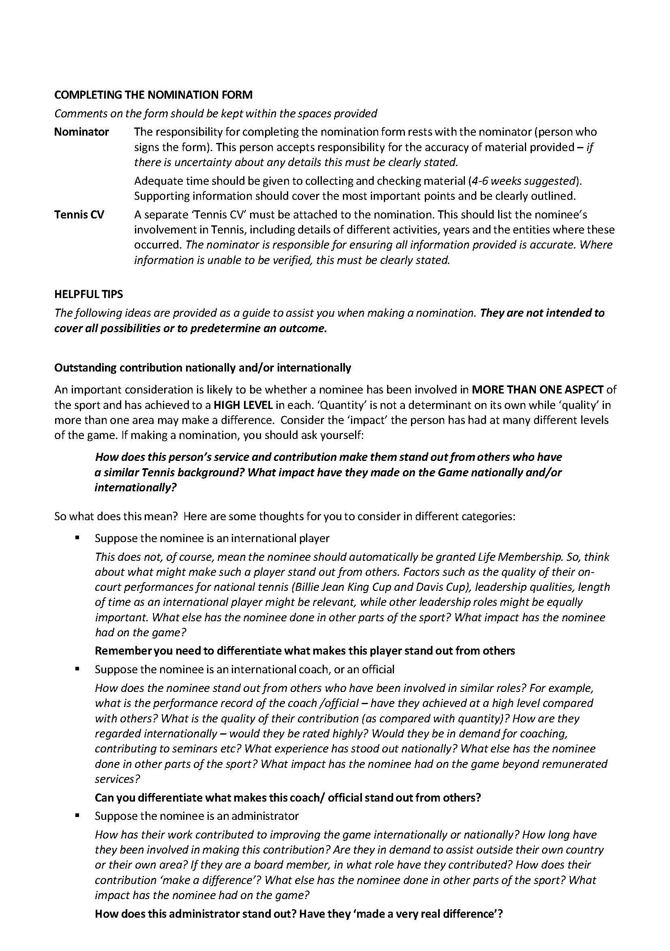



 | NOMINATION FOR TE TOHU TAUMATA MEMBERSHIP  (HONORARY LIFE MEMBERSHIP)  Please read the accompanying nomination guidelines before completing this form

SECTION 1 – Information about the Nominee (the person you are nominating)
Full name
Also known as
Street/Apartment No |  |  | Street name
Suburb |  |  |  | City/town
Post code |  |  | Contact phone
Email address |  |  |  |  | TNZ Service Award (award year)
List any local awards for Tennis
e.g. life membership, service award, regional/civic awards
List any national/international awards for Tennis
e.g. Royal Honours, Tennis NZ/INF awards
List any national/international Tennis qualifications
e.g. NZ Coaching Award, International or NZ Umpiring Award etc
List any national/international Tennis appointments/positions/offices held give details
List details of any Tennis employment
Indicate if these are full-time, part-time positions or short-term contracts

SECTION 2 – Information about the Nominator
Name |  | Position
Name of Zone/Centre | (nominations may made by a zone, centre or Tennis NZ Board)
Contact address
Contact telephone |  | Mobile
Email address

SECTION 3 – Nomination details (please complete all sections)
- Describe the contribution the nominee has made to Tennis in the local area

- Describe the contribution the nominee has made to Tennis nationally

- Describe the contribution the nominee has made to Tennis internationally

- Describe how the nominee stands out from others

Nominator’s signature Date

Section 4 – Check List for Sending Nomination
Has all necessary information been completed on the form?
Has the nominator signed the form?
Have you attached a Tennis CV for the nominee?
PLEASE SEND THIS FORM AND ANY ATTACHMENTS TO

Honours Committee  Tennis New Zealand PO Box 300 130  Albany, Auckland 0632 | Telephone: (09) 528 5428 Email: admin@tennis.kiwi  Nominations close at 5.00pm on 28 July 2023  Late applications cannot be accepted

